LAB 2: Agile Backlog Creation & Sprint Simulation in Jira Project: Clinical Trial Subject Recruitment Engine

Name: Rohanth Ganesha C SRN: PES1UG24AM227
Class: D-Section (5th SEM- AIML)
Screenshots of Epics and User Stories
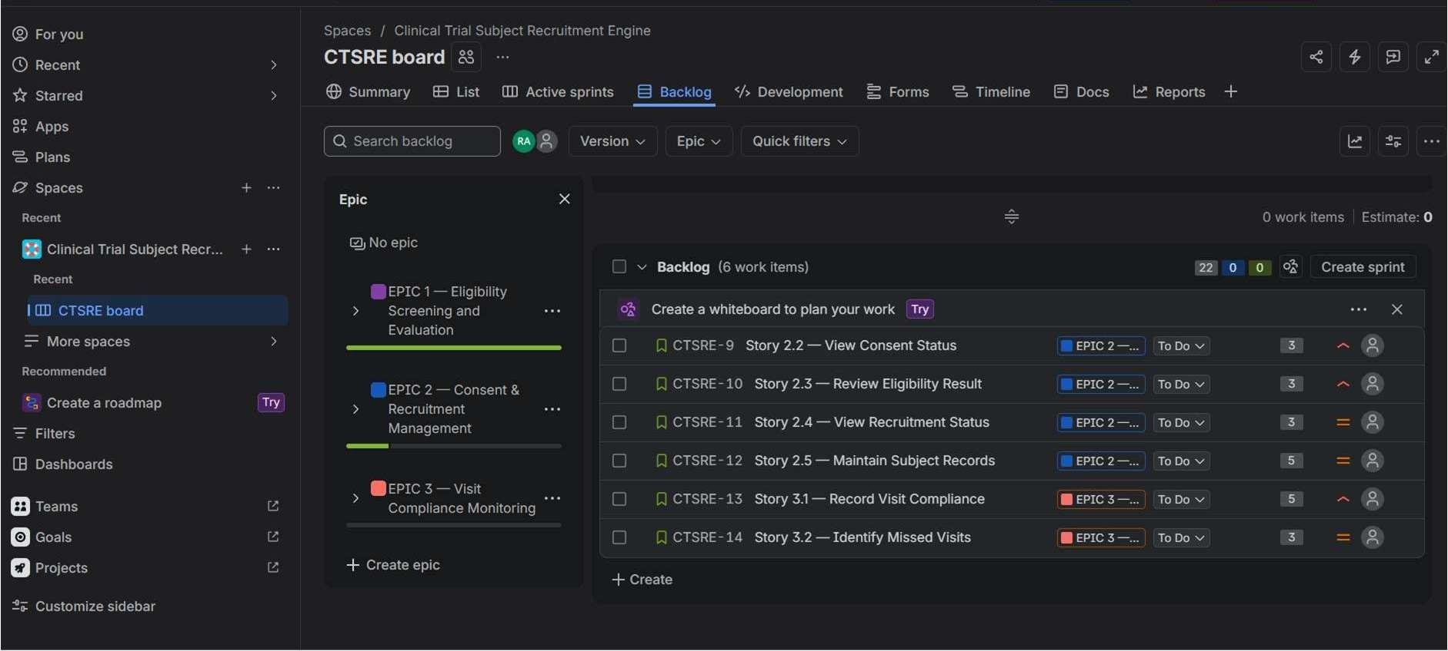
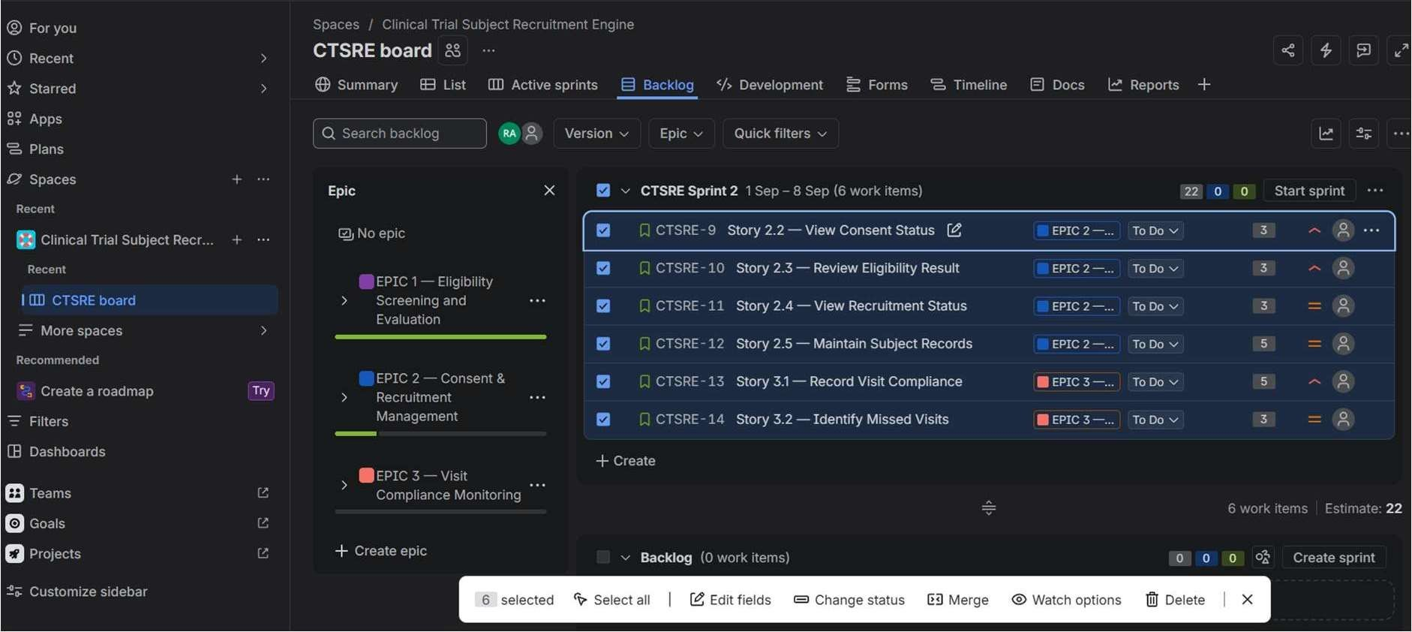

Screenshots of Sprints
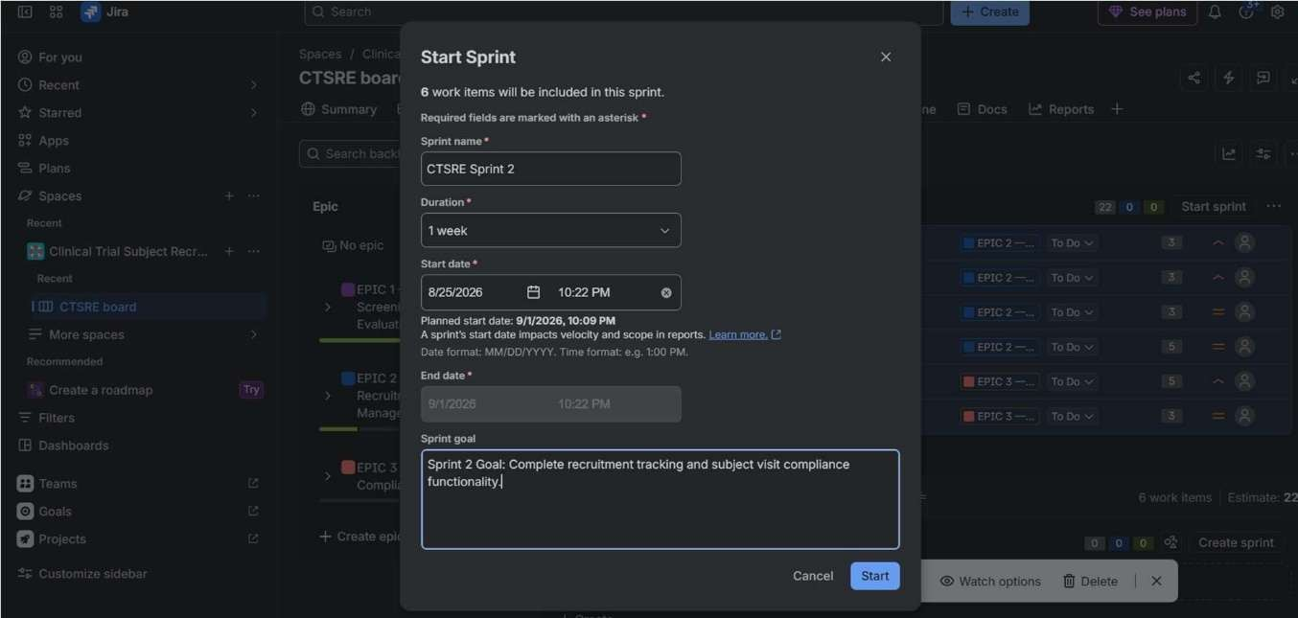
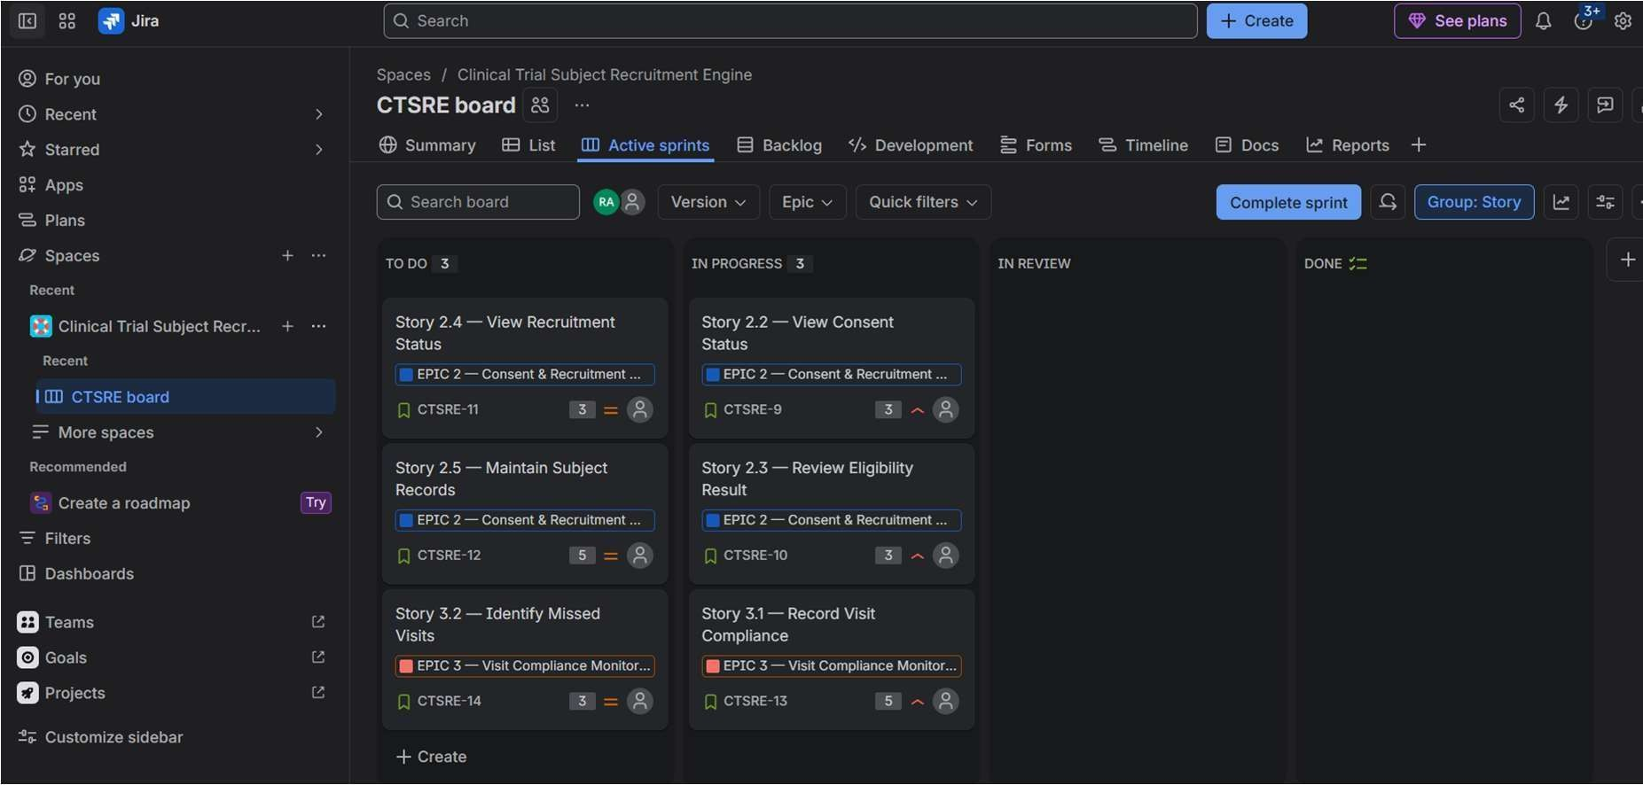
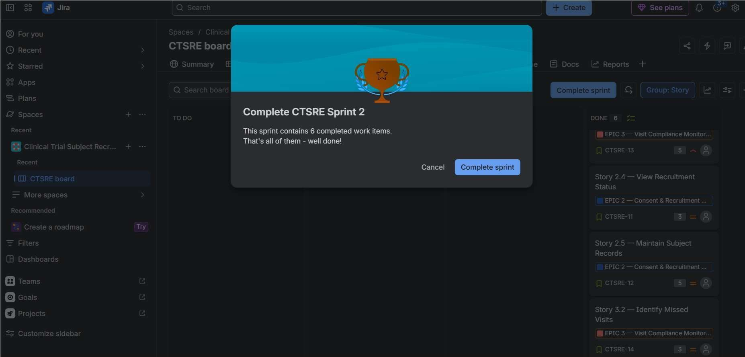

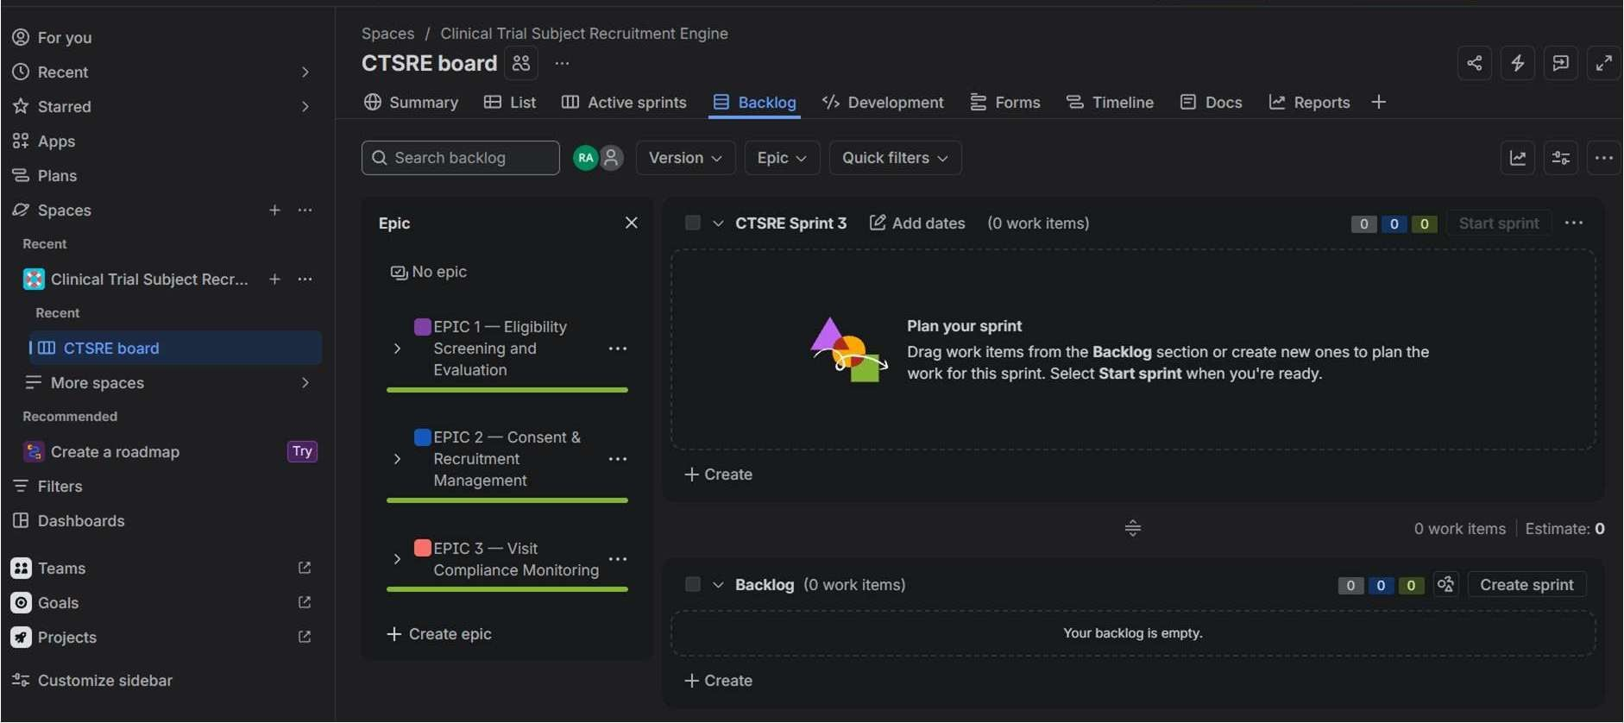

Screenshots of Burndown Chat and summary
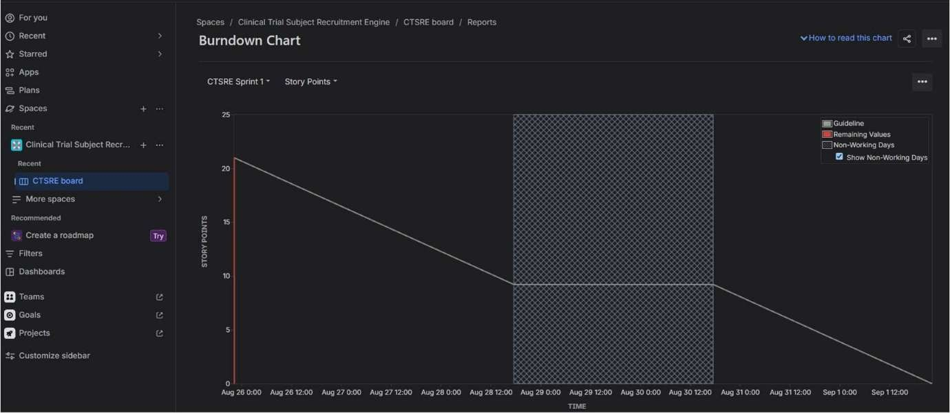
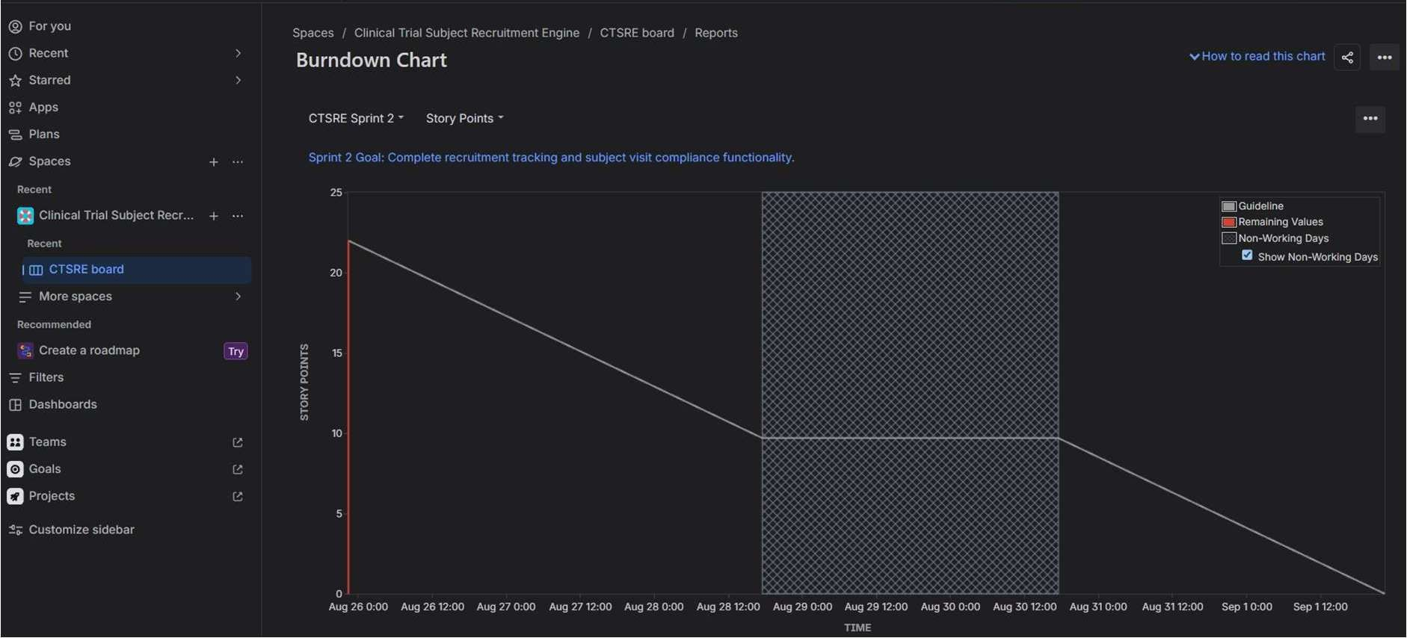

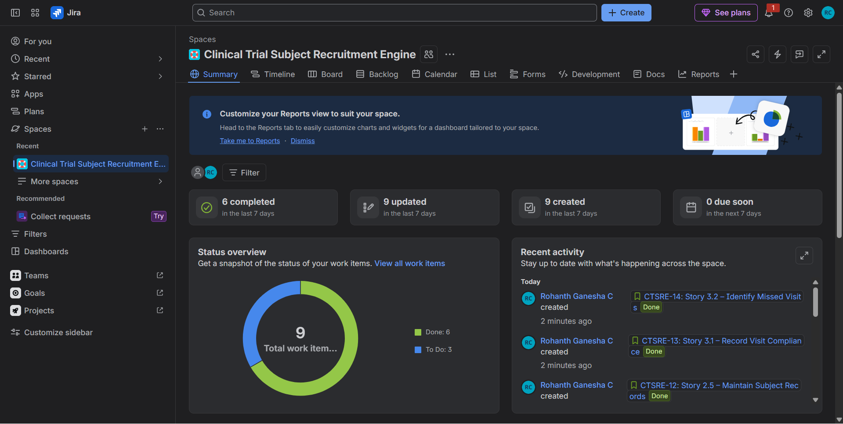
Sprint 1
The first sprint focused on the core eligibility-screening workflow of the Clinical Trial Subject Recruitment Engine. The sprint addressed candidate screening, inclusion/exclusion evaluation, identification of failed criteria, and recording of consent milestones. The work was progressed through the Jira workflow and tracked using story points and sprint progress.

Sprint 2
Complete recruitment tracking and subject visit compliance functionality.

- Did your estimations reflect the actual effort?

Overall, the story point estimations reasonably reflected the actual effort required during the simulated sprints. Smaller stories such as viewing consent status and displaying failed criteria were assigned 3 points because they involved relatively straightforward functionality. More complex stories such as evaluating inclusion/exclusion criteria, recording consent milestones, maintaining subject records, and recording visit compliance were assigned 5 points because they involved greater complexity and uncertainty. Since the sprint was simulated, the story points provided a relative estimate rather than an exact measurement of development time

- Was your backlog well-prioritized?

Yes. The backlog was prioritized according to the importance of each feature to the clinical trial recruitment process. Eligibility screening was given the highest priority because determining whether a candidate satisfies the trial criteria is the core purpose of the recruitment engine. Consent tracking and eligibility review were also given high priority because they support safe and controlled recruitment. Recruitment-status and visit-compliance features were prioritized after the core screening workflow.

- How did your simulated sprint align with your plan?

The simulated sprints generally aligned with the planned objectives. Sprint 1 focused on the core eligibility screening workflow, including candidate screening, inclusion and exclusion evaluation, failed-criteria identification, and consent milestone recording. Sprint 2 focused on recruitment management and visit compliance. Stories were moved through To Do, In Progress, and Done to simulate development progress. The sprint structure helped demonstrate how a prioritized backlog can be converted into time-boxed development work.

- What insights did the burndown chart give about your team's capacity?

The burndown chart provided a visual indication of how quickly the team was completing its committed work. It showed the amount of work remaining throughout the sprint and allowed actual progress to be

Table with all the epics and user stories

Epic | Story ID / Story | As a | I want to | So that
EPIC 1 – Eligibility Screening and Evaluation | Story 1.1 – Submit Pre-Screening Survey | Trial Candidate | submit my pre-screening survey responses | my eligibility can be evaluated against the trial criteria
 | Story 1.2 – Evaluate Eligibility | Clinical Researcher | have the system evaluate candidate responses against inclusion and exclusion criteria | candidate eligibility can be determined accurately
 | Story 1.3 – View Eligibility Status | Trial Candidate | view my eligibility status | I know whether I am eligible for the clinical trial
 | Story 1.4 – View Failed Criteria | Trial Candidate | view the specific failed eligibility criteria when I am ineligible | I understand why I was not eligible
EPIC 2 – Consent & Recruitment Management | CTSRE-9 – Story 2.2 – View Consent Status | Clinical Researcher | view a candidate's consent status | I can verify the candidate's consent progress
 | CTSRE-10 – Story 2.3 – Review Eligibility Result | Clinical Researcher | review a candidate's eligibility result | I can make appropriate recruitment decisions
 | CTSRE-11 – Story 2.4 – Review Recruitment Status | Clinical Researcher | review a candidate's recruitment status | I can monitor the candidate's progress through recruitment
 | CTSRE-12 – Story 2.5 – Maintain Subject Records | Clinical Researcher | maintain candidate subject records | recruitment information remains organized and available for review
EPIC 3 – Visit Compliance Monitoring | CTSRE-13 – Story 3.1 – Record Visit Compliance | Clinical Researcher | record a candidate's visit compliance | I can track whether required visits are being completed
 | CTSRE-14 – Story 3.2 – Identify Missed Visits | Clinical Researcher | identify missed candidate visits | I can follow up on compliance issues promptly

compared with the expected progress guideline. The simulation indicated that the team could complete the selected workload within the sprint when the work was properly prioritized and divided into manageable stories. In a real project, repeated sprint results could be used to establish a more reliable team velocity for future sprint planning

